User Interface / User Experience

# Home Page

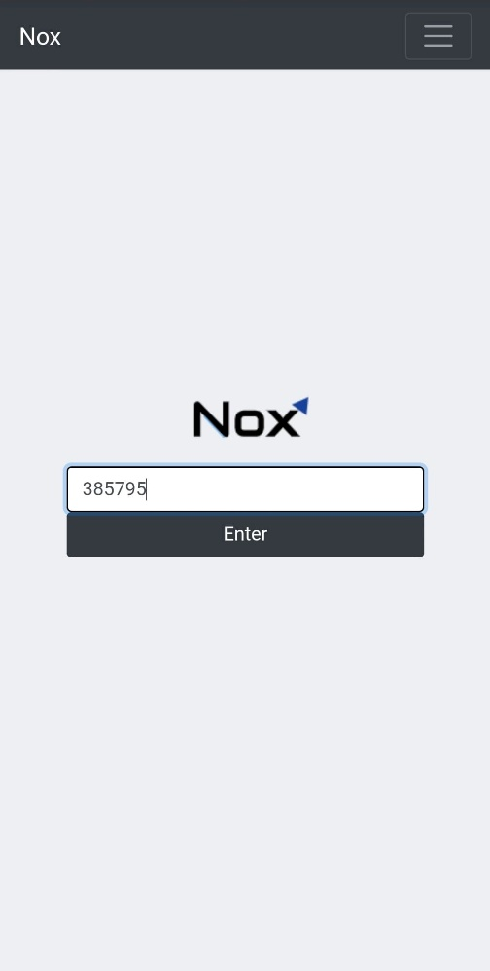

Enter unique code to join the session created by the professor

Dropdown includes:

* Home
* Professor Login
* Feedback
* GitHub

# Student Interface

Mobile friendly for students!

Simple and appealing design – easy for students to use without causing much distraction in class

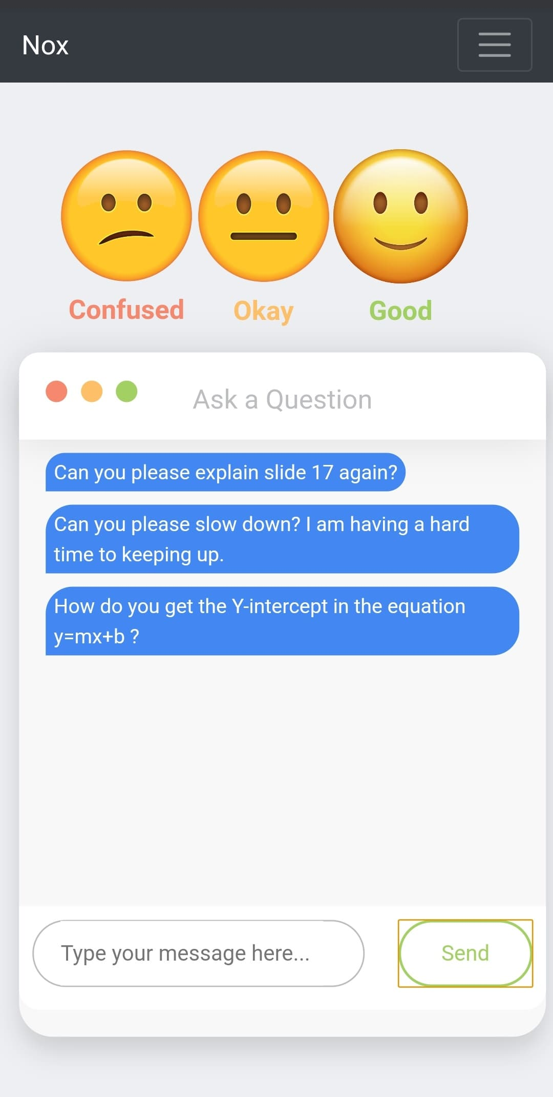

Send private anonymous messages to the professor

Rate how you are currently feeling about the material being taught

# Teacher Interface

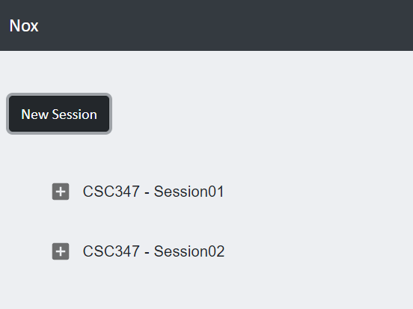

View details of a previous session or create a new session

Graph how the students are feeling in real-time

Receive chat from all students in the same feed

# New Session

Total Students: 3

# Existing Session (Analytics)

Play through the data like a timelapse, or scrub through it manually

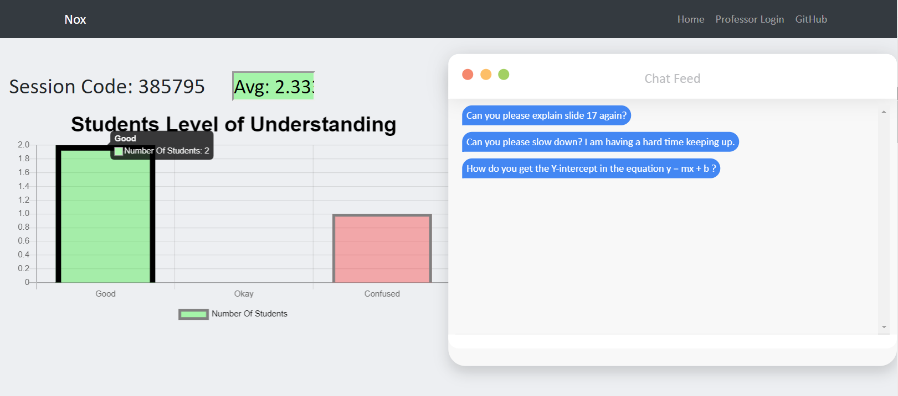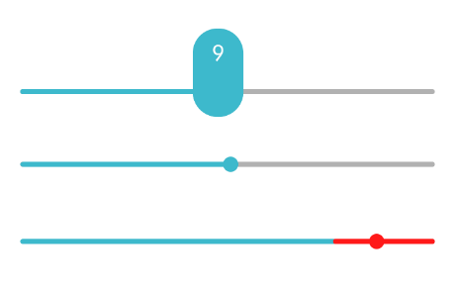Alternate View

Generates raw session data into JSON format

Export Raw Data

Duration: 50%

Duration: 50%

Export Raw Data